**CICD EXPERIMENT – 9**

**Name: Aditya Agarwal   
Sap id:500069294  
Roll No:R171218007**

**Uploading artifacts on Nexus server using Command Line**

1. Visit **sonatype.com/nexus/repository-oss/download** to download nexus server

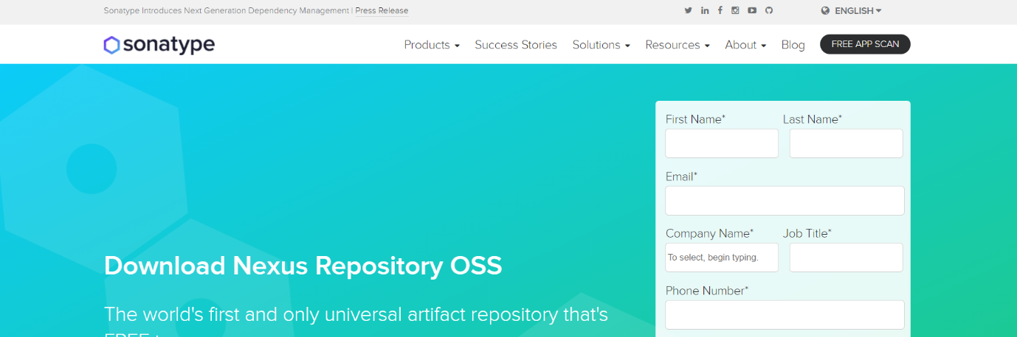

Go to the location where Nexus is installed in your machine and open the bin folder. Find “nexus.exe” file and copy its path

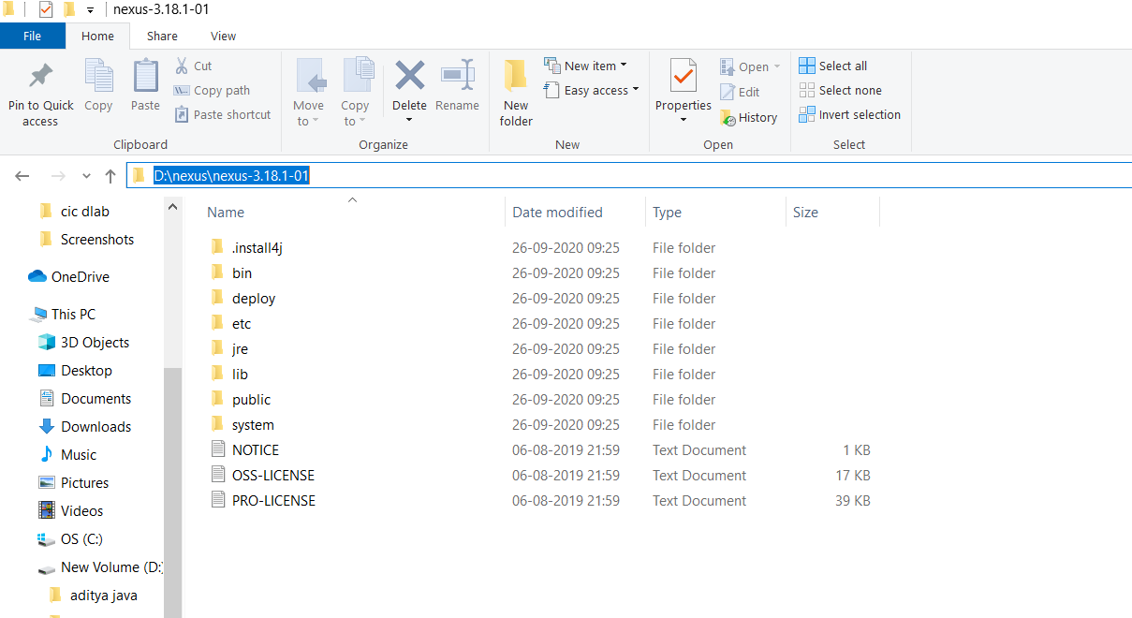

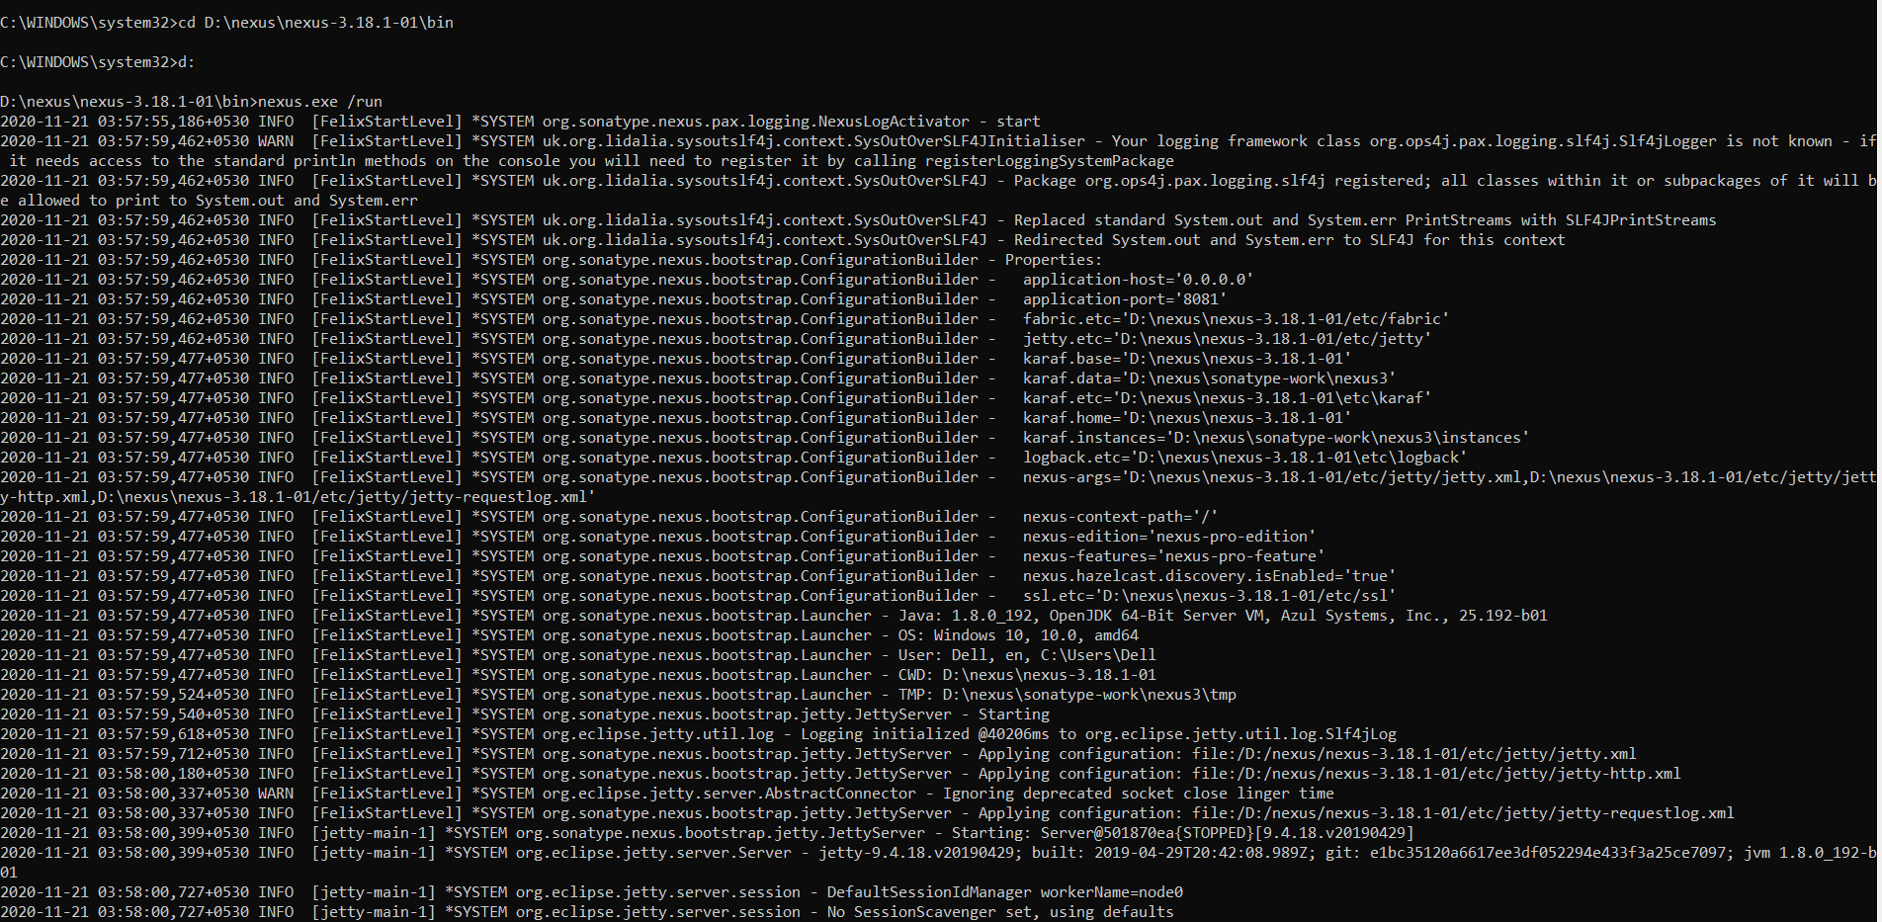

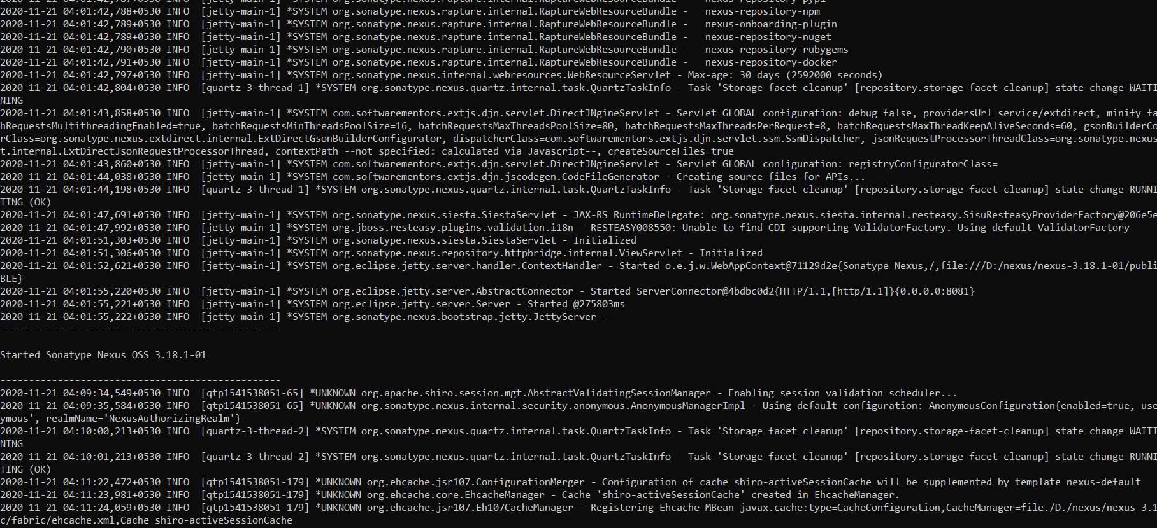

Create a new repository and copy its URL

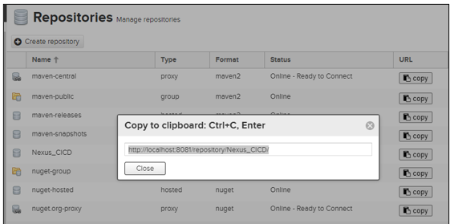

add the tag server in apache-maven-3.6.3

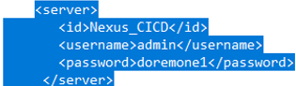

open the pom.xml file and Add the snapshotRepository tag into pom.xml file and URL.

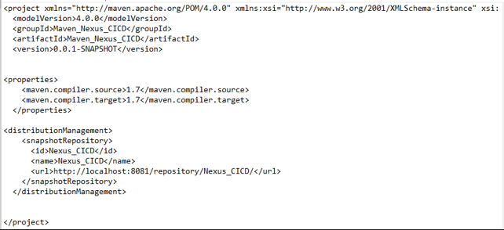

Now run mvn clean

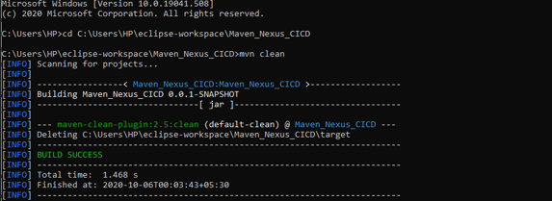

Mvn install

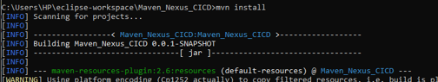

Now mvn deploy to deploy build jar

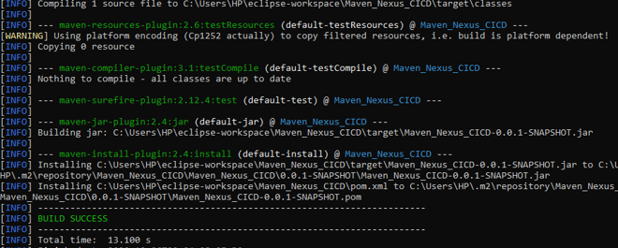

Nexus repository

